ANALYSIS OF FACTORS INFLUENCING CAMPUS PLACEMENTS

CSE3020 – DATA VISUALISATION

PROJECT BASED COMPONENT REPORT

By
Shruti Garg
Rahul Gudivada
Glenn Varghese George
Advika Srivastava
Shreya Rastogi

Register Number
19BCE0994
19BCE2469
19BCE2495
19BCE2217
19BCE0756


School of Computer Science and Engineering

May 2021

DECLARATION

I hereby declare that the report entitle “Analysis of Factors Influencing Campus Placement” submitted by me, for the CSE3020 DATA VISUALISATION (EPJ) to VIT is a record of bonafide work carried out by me under the supervision of Dr.S.VENGADESWARAN .
I further declare that the work reported in this report has not been submitted and will not be submitted, either in part or in full, for any other courses in this institute or any other institute or university.

Place : Vellore
Date : 07/06/2021

Signature of the Candidate

Shruti Garg
Rahul Gudivada
Glenn Varghese George
Advika Srivastava
Shreya Rastogi

CONTENTS
P.No
- ABSTRACT
- INTRODUCTION TO THE PROJECT
- OBJECTIVE
- PROBLEM STATEMENT
- FUNCTIONAL REQUIREMENTS
- DATA ABSTRACTION
- DESIGN OF THE PROPOSED SYSTEM
- ALGORITHMIC DESIGN
- TASK ABSTRACTION
- DASHBOARD IMPLEMENTATION
- RESULT ANALYSIS
- CONCLUSION
- APPENDIX
- SCREEN SHOTS
- SAMPLE CODING

- ABSTRACT:

Campus placements help the students to get a platform for themselves and they don’t have to struggle themselves in the search for a job. Hence it is important to properly analyze the whole process of placements. In order to perform thorough data analysis, we chose a data set that consists of Placement data of students on the campus. It includes secondary and higher secondary school percentages and specialization. It also includes degree specialization, type and Work experience and salary offers to the placed students.

- INTRODUCTION TO THE PROJECT:

  - OBJECTIVE:

It is important to have prior research about the placement trends before applying for the same as it will help achieve better results in the process. The process of data visualization holds a lot of significance in doing so. Since there are a lot of students in a college and understanding the data trends manually will cause great difficulty, it is much easier to analyze and understand data if its in a visual form like a bar graph or pie chart rather than in a textual form like spreadsheets. Understanding data quickly also meansthat students can make decisions based on that data much more quickly as well. It is sometimes possible to even estimate future trends using Data Visualization. This gives a huge edge to students as they can move ahead of their competitors by analyzing future placement trends.

  - PROBLEM STATEMENT:

To understand the process of placements in a college, how the system works, and what are the major factors that affect the placement statistics and influence the candidates participating in it.

  - FUNCTIONAL REQUIREMENTS:

Along with analysis and visualization of data, our project will also provide a prediction model which will help students understand their chances of getting placed or not. The applicability of this feature will help students to understand what are the factors they need to improve in order to get a good placement package.

- DATA ABSTRACTION:

Dataset Type:
The data set used for this project is a table which consists of Placement data of students in a XYZ campus. It includes secondary and higher secondary school percentages with specialization. It also includes degree specialization, type and Work experience and salary offers to the placed students.

Data Types:
The data types used here are attributes and items.
The dataset table of campus placements contains 15 attributes and 215 items.

Attribute Semantics:

- Sl_no: Serial Number.
- gender: The gender of the student. Male=”M”, Female=”F”
- ssc_p:Secondary Education percentage of students in 10th Grade
- ssc_b: Board of Education for 10th Grade - Central/ Others
- hsc_p: Higher Secondary Education percentage of students in 12th Grade
- hsc_b: Board of Education for 12th grade - Central/ Others
- hsc_s:Specialization in Higher Secondary Education
- degree_p: Degree Percentage scored by student
- degree_t: Under Graduation(Degree type)- Field of degree education
- workex: Work Experience
- etest_p: Employability test percentage ( conducted by college)
- specialisation: Post Graduation(MBA)- Specialization
- mba_p: MBA percentage
- status: Status of placement- Placed/Not placed
- salary: Salary offered by corporate to candidates

The attributes can be classified as categorical and ordered as follows:

Categorical | Ordered
Gender : Male- M , Female- F  ssc_b: Central / Other  hsc_b: Central / Other  hsc_s: Science/ Commerce/ Arts  degree_t: Sci&Tech / Comm&Mgmt  workex: Yes / No  specialisation: Mkt&HR/ Mkt&Fin  status: Placed / Not placed | Sl_no  ssc_p  hsc_p  degree_p  etest_p  mba_p

Target Identification:

We have focused on the following objectives or targets for our project:
- Does the candidate's gender ( male or female ) have any role in placement?
- Which factors influenced a candidate in getting placed?
- Does 10th and 12th percentage matter for one to get placed?
- Which degree specialization is much demanded by corporate?
- Determine the average salary offered during placements and its factors.
- Play with the data conducting all statistical tests.

- DESIGN OF THE PROPOSED SYSTEM:

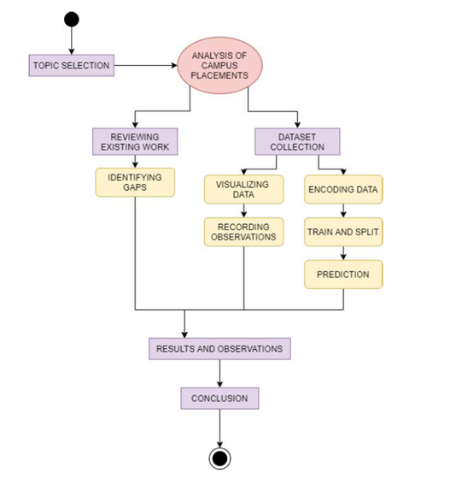

Dataset Collection:
We use a dataset from kaggle – “Factors affecting campus placements” for our data.
Visualizing data:
Here we find the best graphical representation of our data. i.e. bar charts, pie charts, box plot etc.

Recording Observations:
We record the observations from the data.
Encoding Data:
Here we translate the data into a visual element on the plots we are making.
Train and split:
We divide the training sessions by body regions into two: one for training and one for testing.
Prediction:
Here we Predict whether the candidate will be placed or not based on some
predictors.

- ALGORITHMIC DESIGN:

Classification Algorithms Used:
1. Logistic Regression: Logistic regression is used to describe data and to explain the relationship between one dependent binary variable and one or more nominal, ordinal, interval or ratio-level independent variables.
2. Decision Tree: Decision trees use multiple algorithms to decide to split a node into two or more sub-nodes. The creation of sub-nodes increases the homogeneity of resultant sub-nodes.The decision tree splits the nodes on all available variables and then selects the split which results in most homogeneous sub-nodes.

- TASK ABSTRACTION:
- ANALYZE -
  - Consume:
We have chosen a dataset which provides us with a table containing factors which influence the campus placements. These factors can be analyzed and compared to find out some trends and important factors.
  - Produce:
Our production goal is to “derive”. From the present dataset we can produce a prediction model which will help students understand their chances of getting placed or not. The applicability of this feature will help students to understand what are the factors they need to improve in order to get a good placement package.

- SEARCH -
We are doing an analysis of all the factors to find out their role in placements and thus don’t have any fix target. Also the location is not known as any of the factor might play a prime role. So as both target and location are unknown, our search method is “explore”.
- QUERY-
After the searching mechanism we have provided a comparison of all the factors as well as a provide a comprehensive view i.e. “summary” of these factors through histogram.

Using one or two variables:
● Does the candidate's gender ( male or female ) have any role in placement?
● Does 10th and 12th percentage matter for one to get placed?
● Which degree specialization is much demanded by corporate?
● Determine the average salary offered during placements and its factors.
Using all the attributes:
● Which factors influenced a candidate in getting placed?
● Play with the data conducting all statistical tests.
● To provide a summary of all the factors and show correlation between them.

- DASHBOARD IMPLEMENTATION:
Using VOILA:
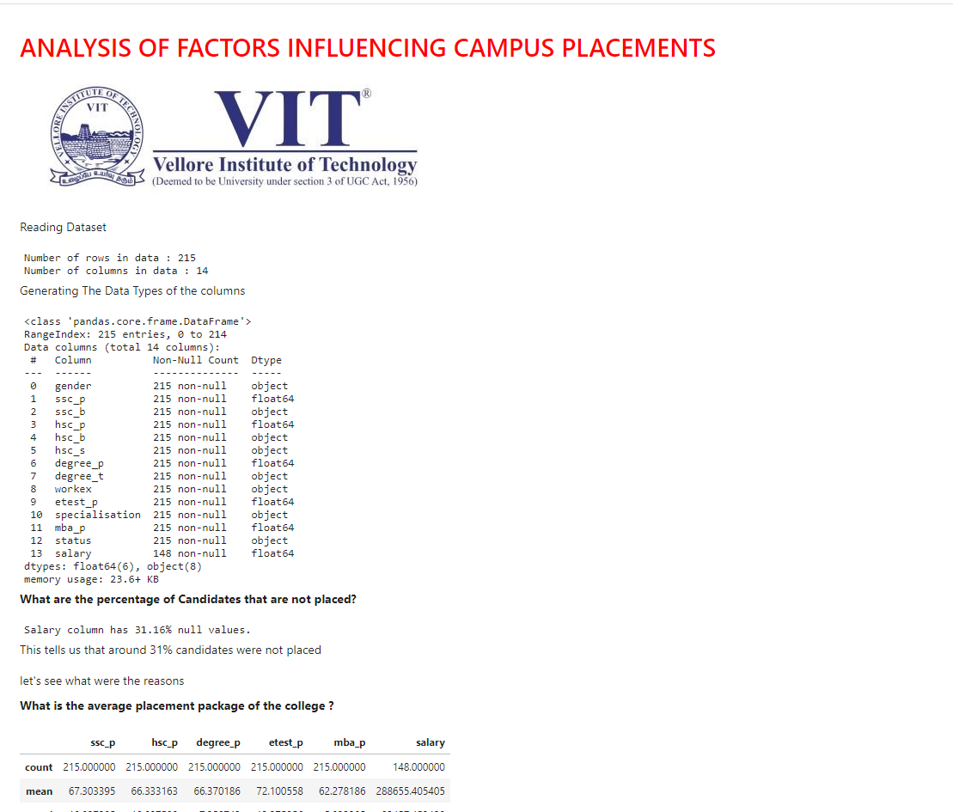

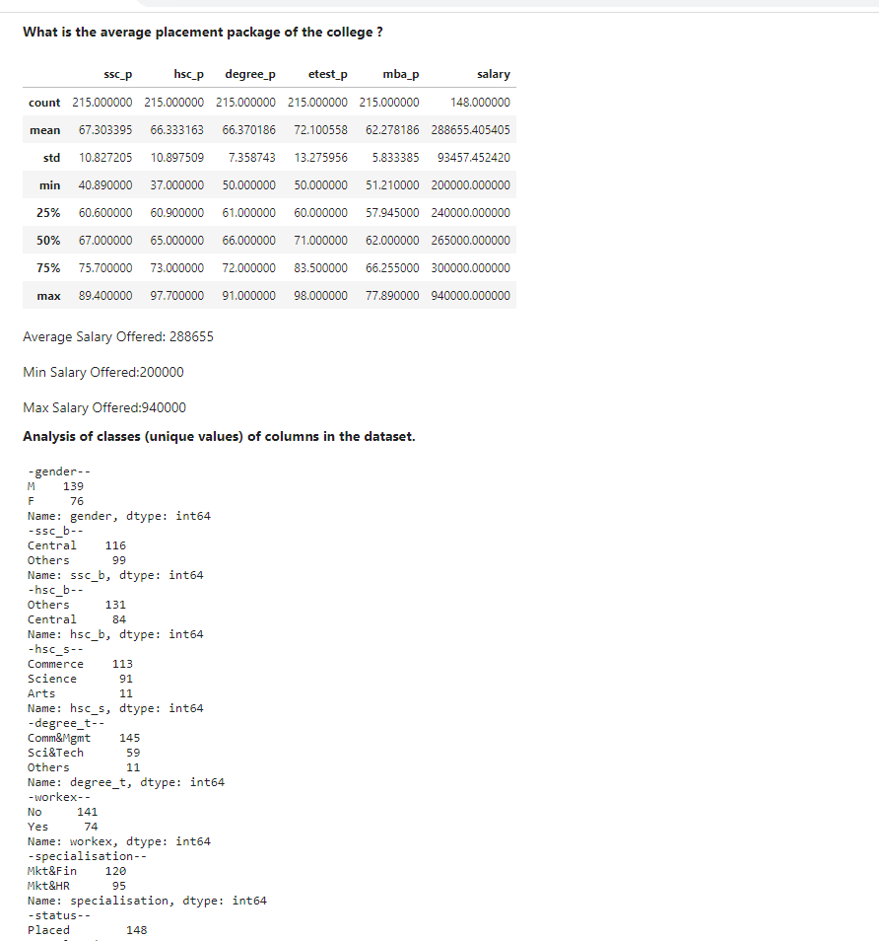

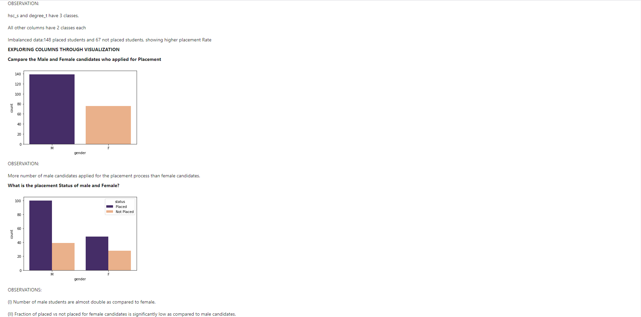

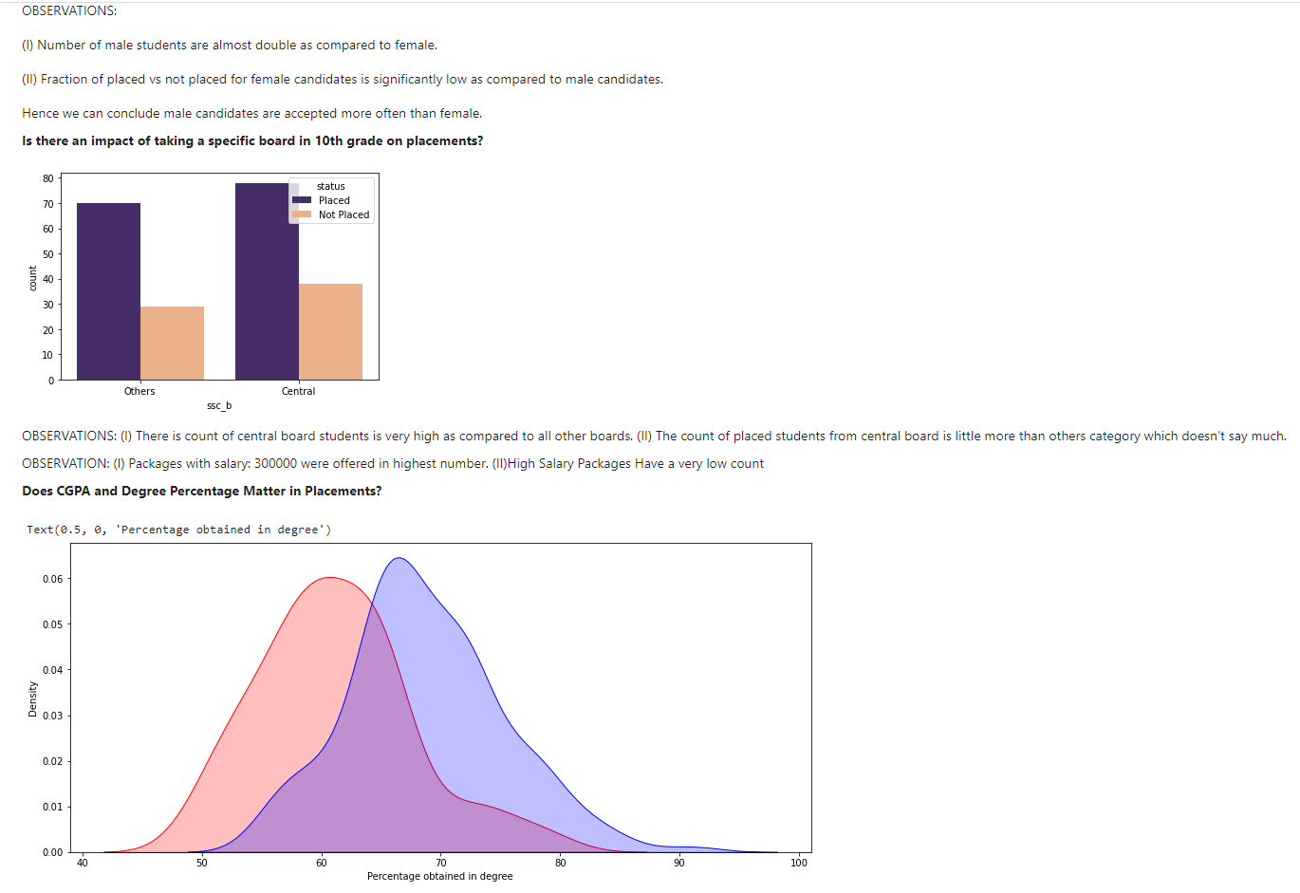

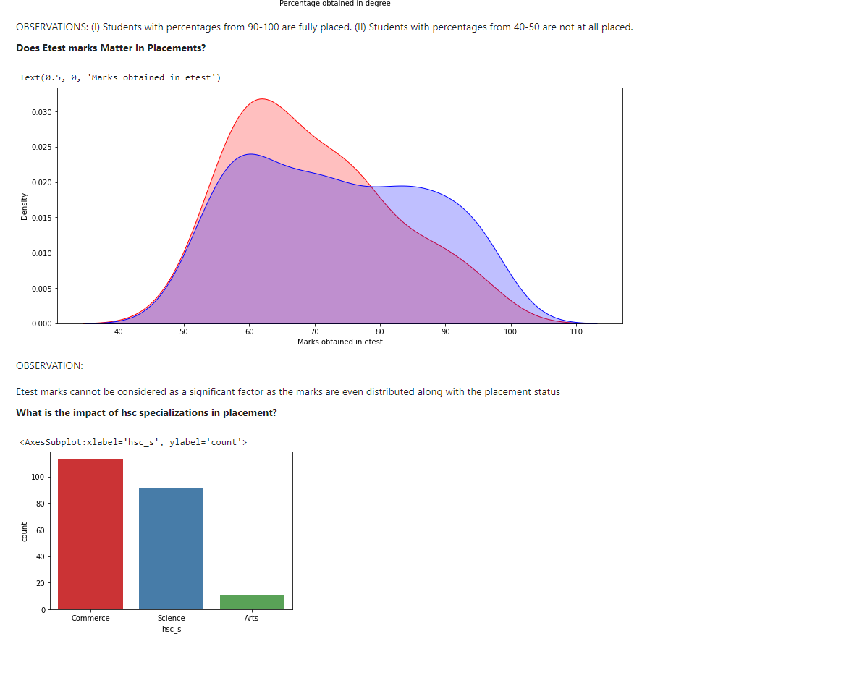

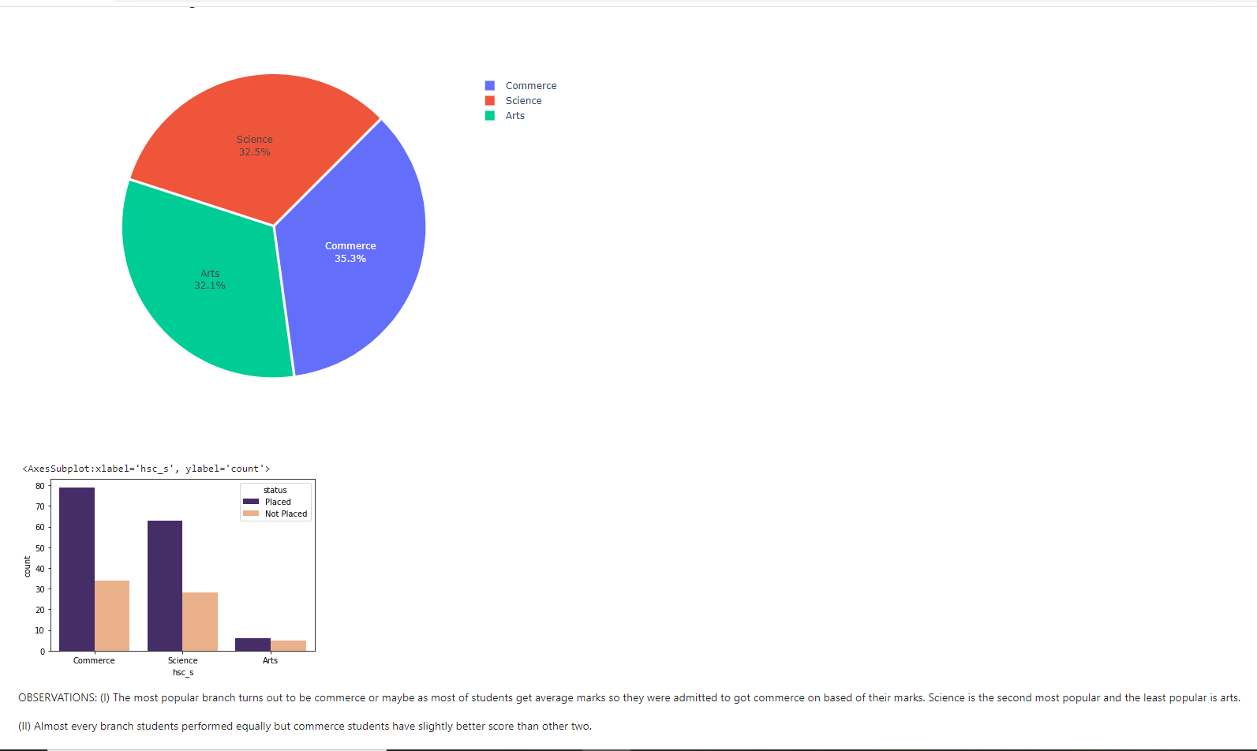

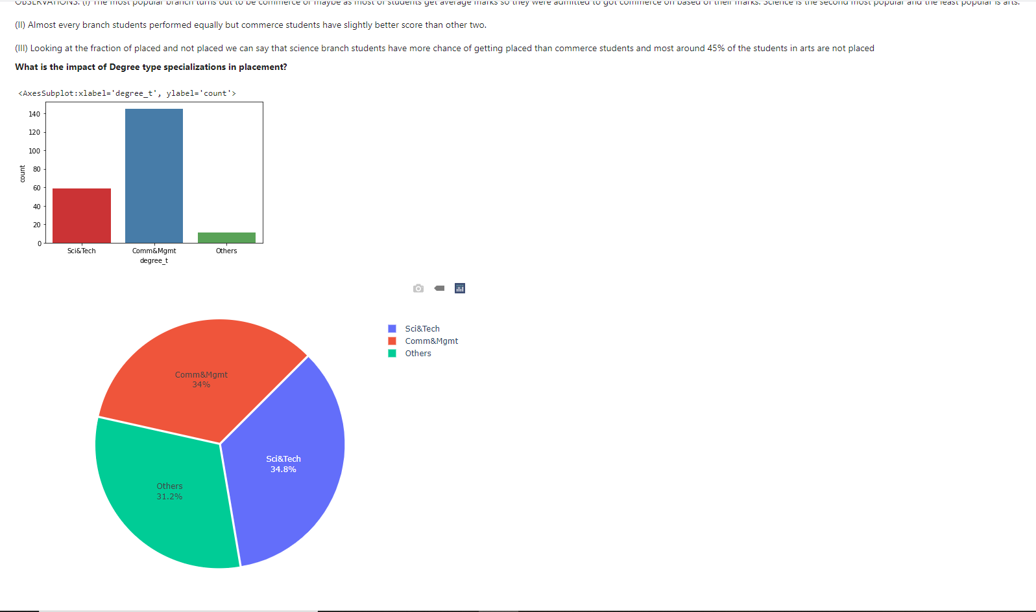
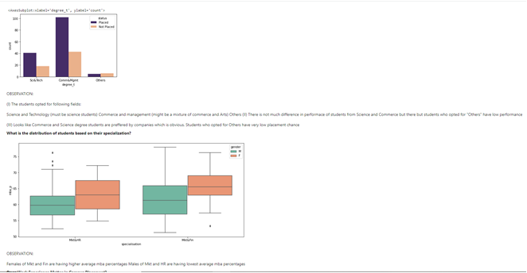

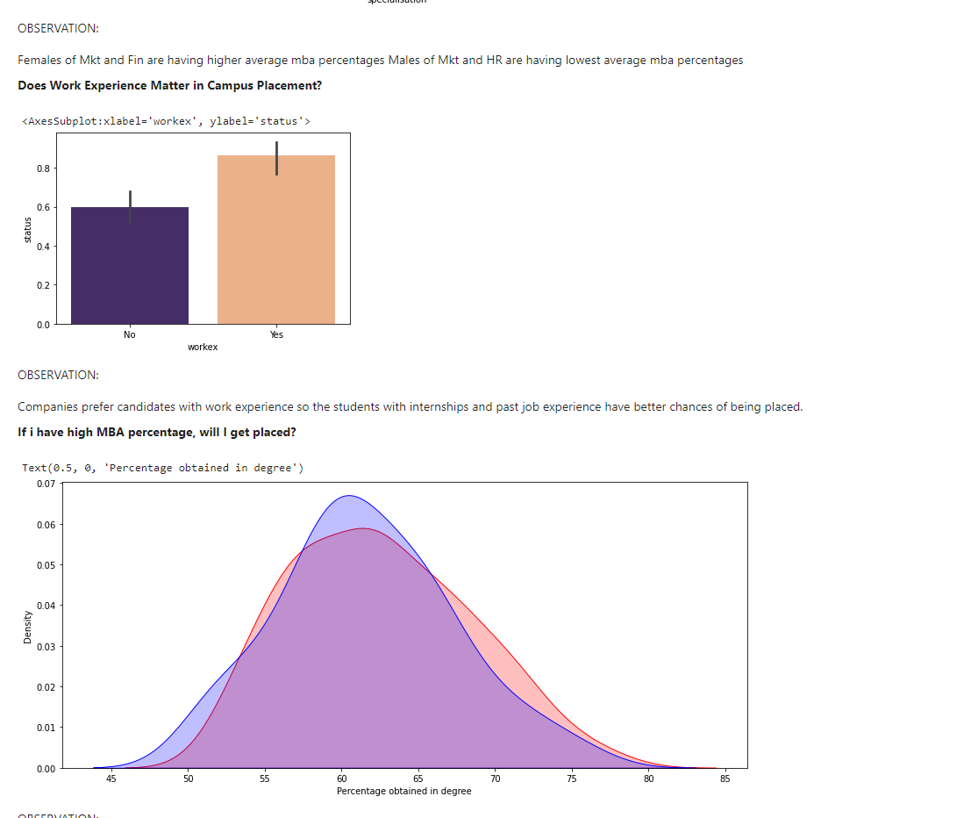
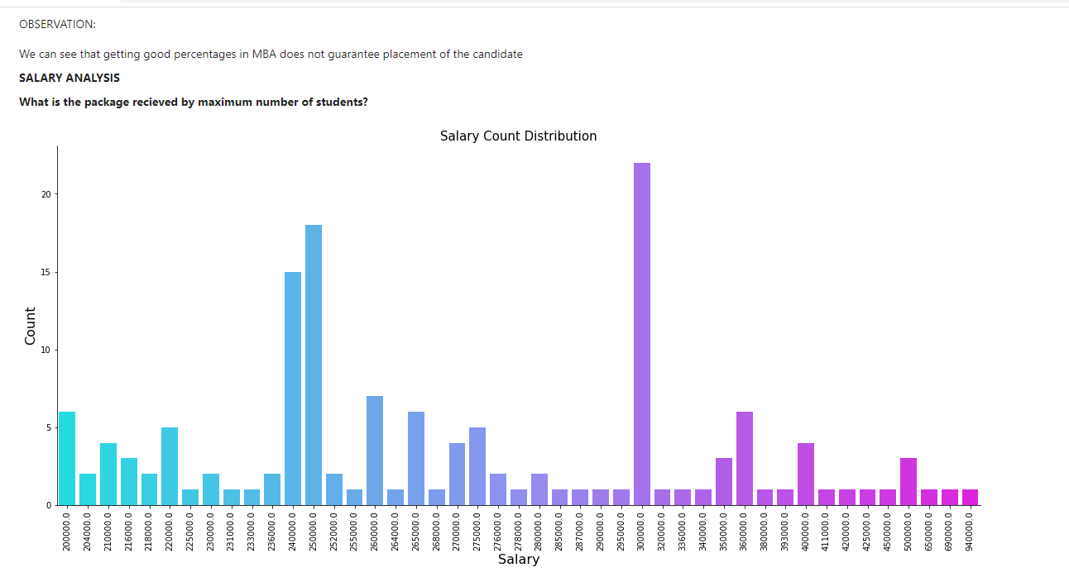

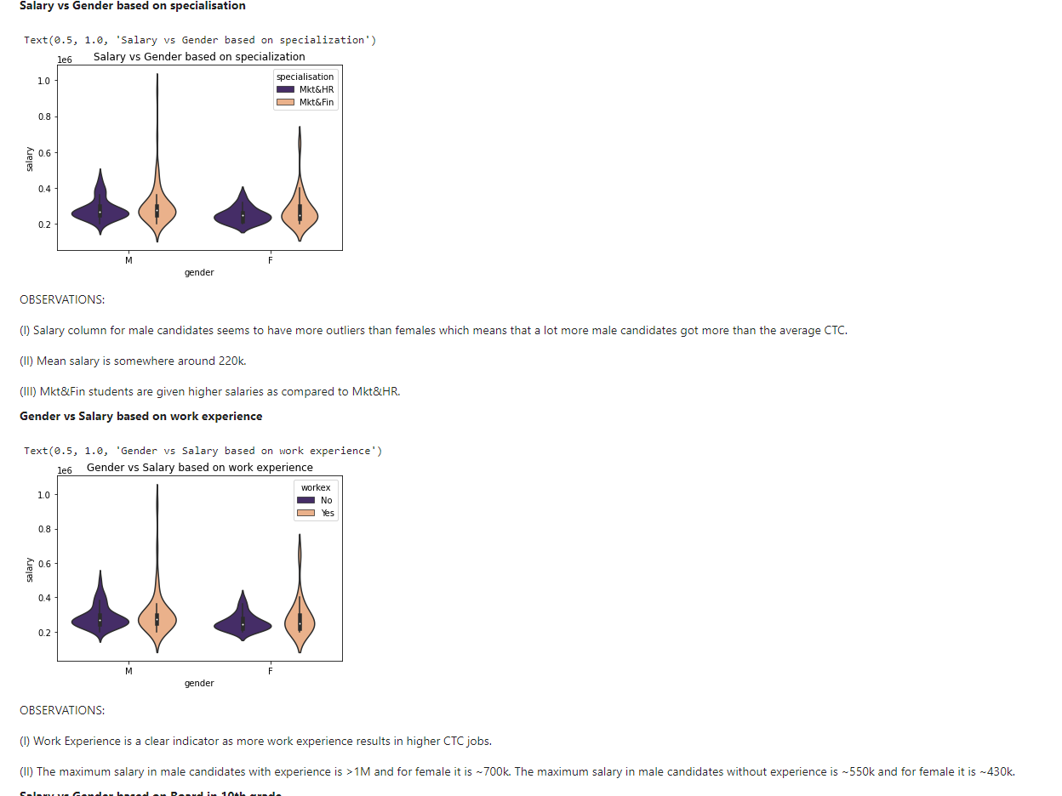
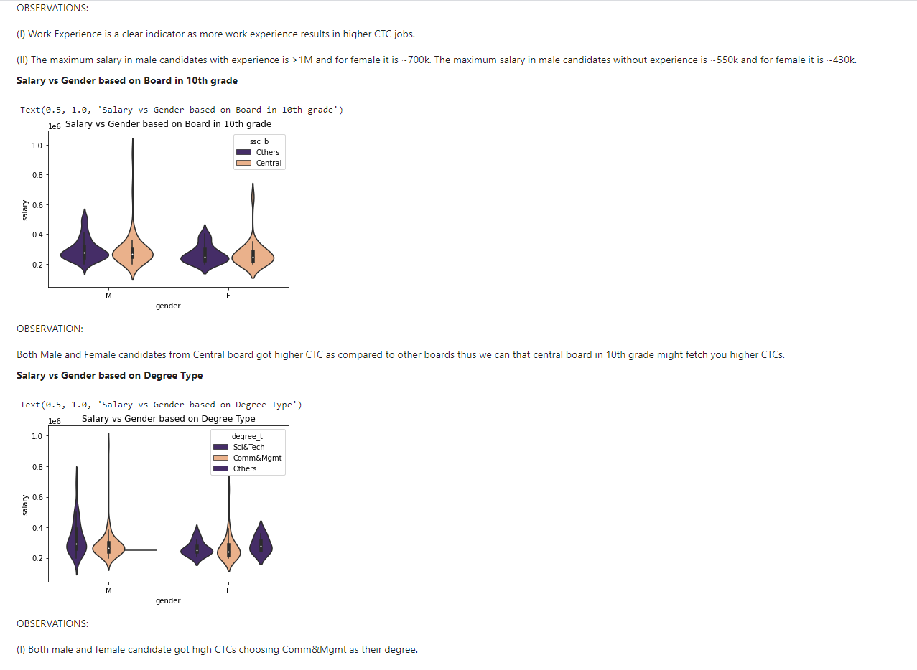

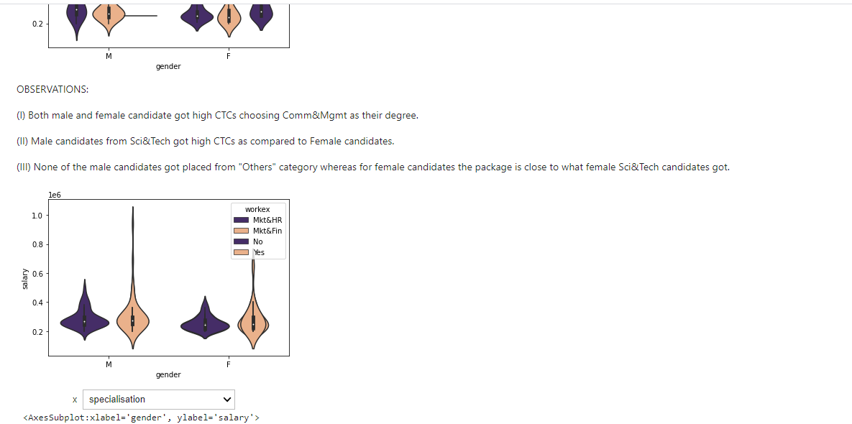

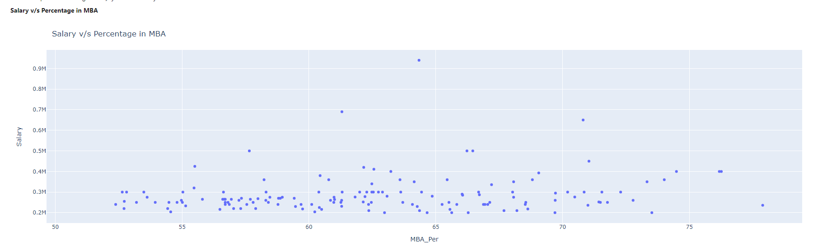
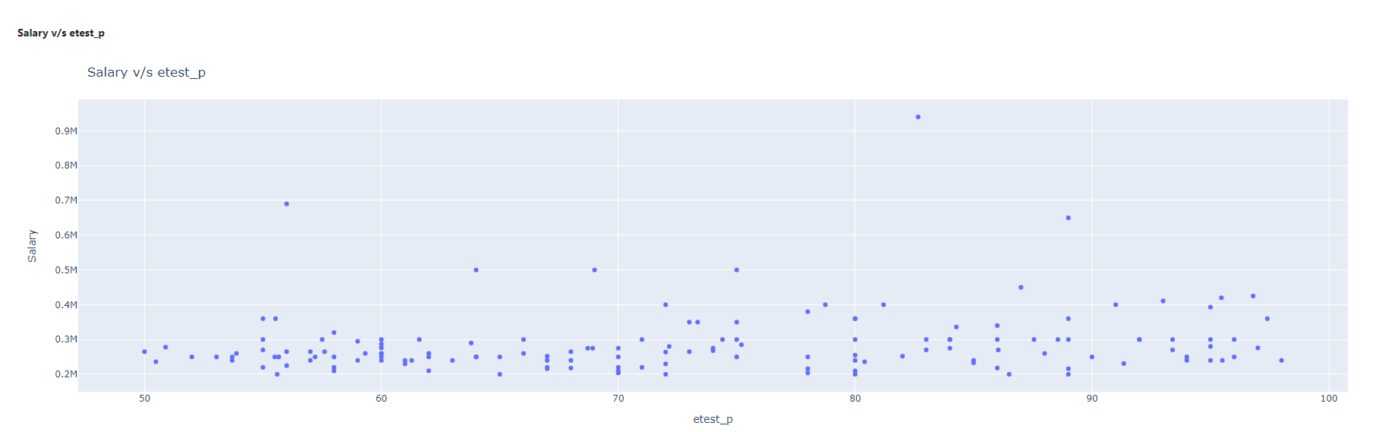
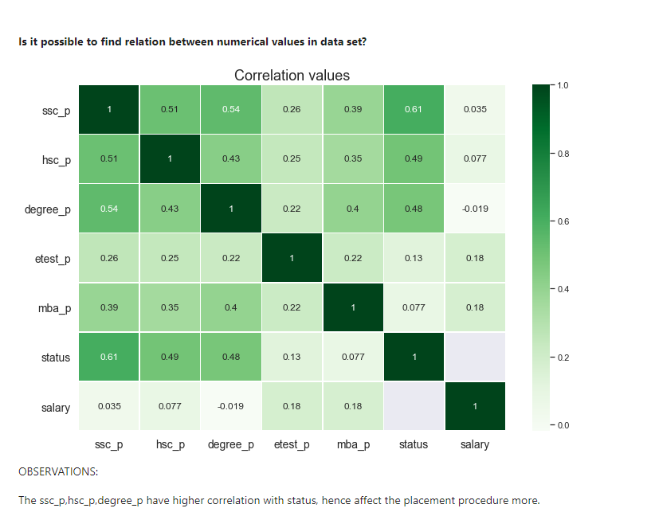
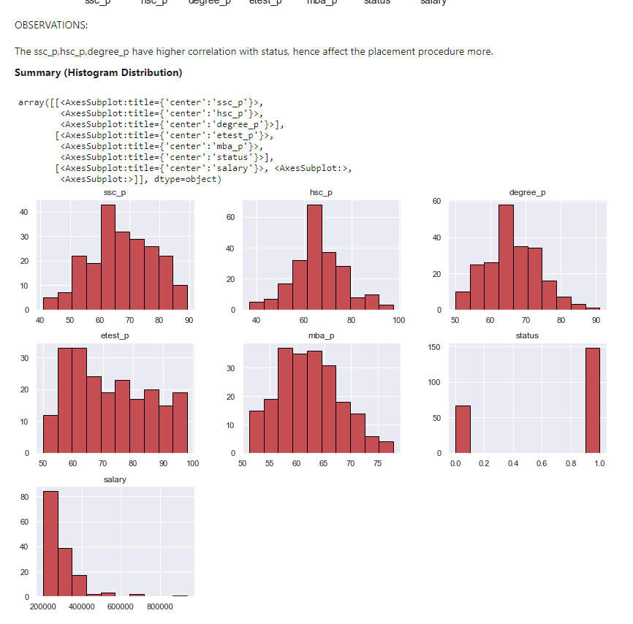

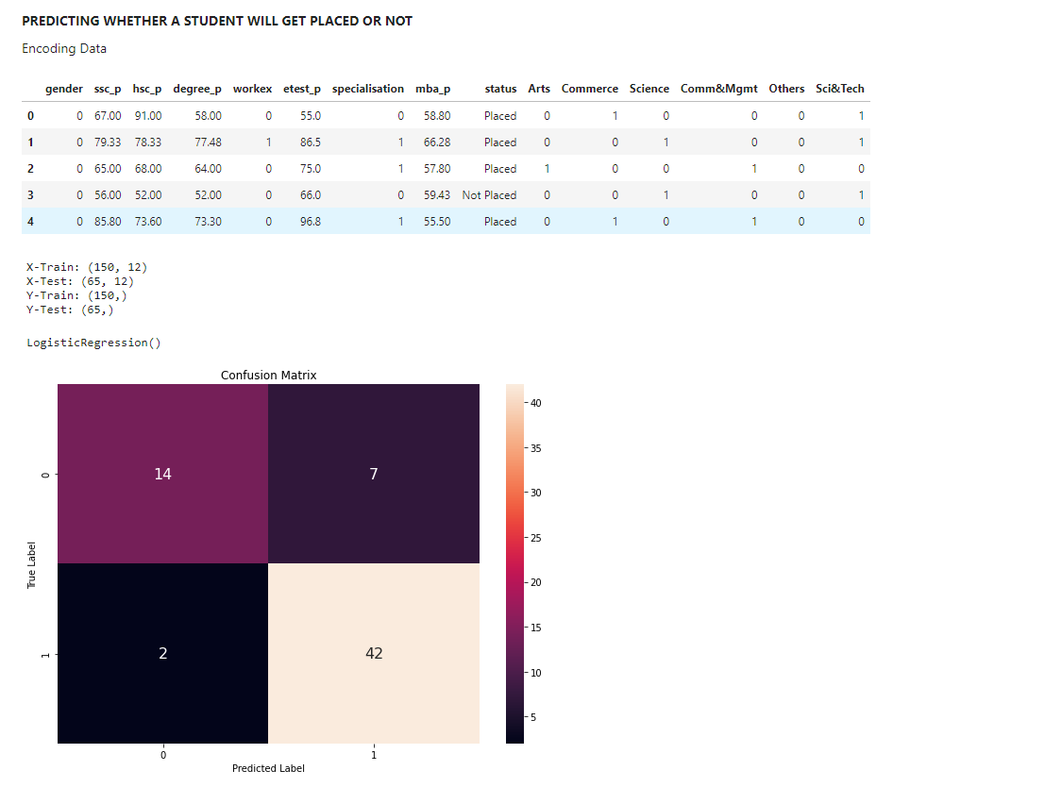

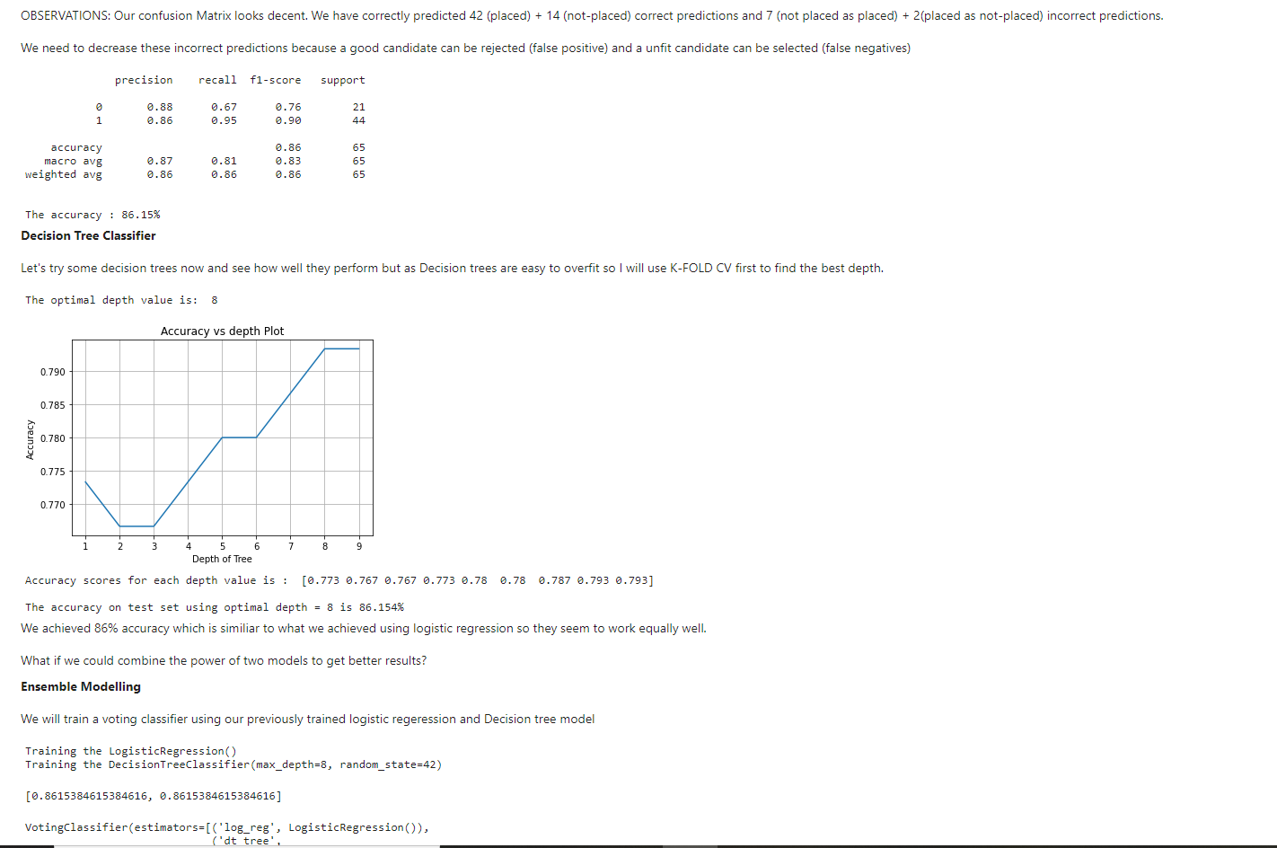
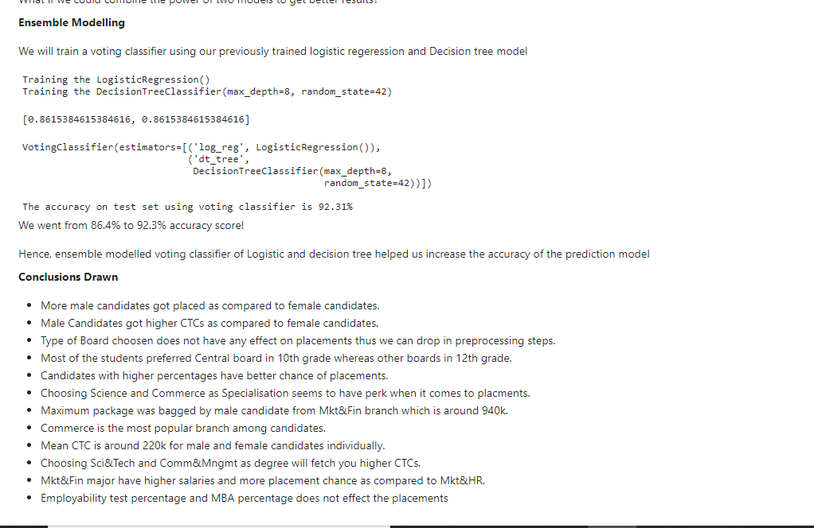

- RESULT ANALYSIS:

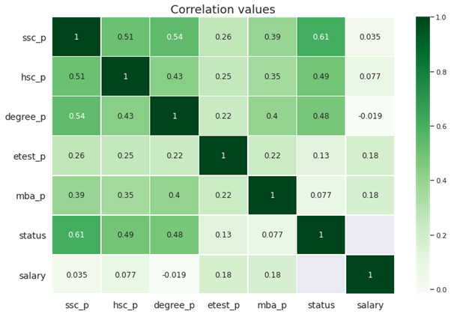
The ssc_p,hsc_p,degree_p have higher correlation with status, hence affect the placement procedure more.
Summary(Histogram Distribution)
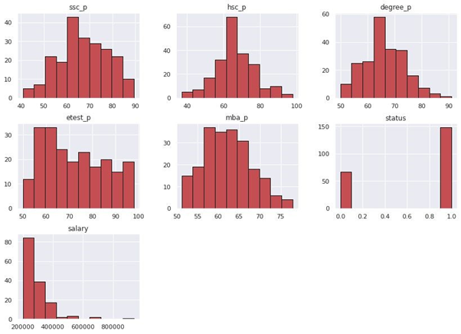

- CONCLUSION:
● Male Candidates got higher CTCs as compared to female candidates.
●More male candidates got placed as compared to female candidates.
● Type of Board chosen does not have any effect on placements thus we can drop in preprocessing steps.
● Most of the students preferred the Central board in 10th grade whereas other boards in 12th grade.
● Candidates with higher percentages have better chances of placements.
● Choosing Science and Commerce as Specialisation seems to have perks when it comes to placements.
● Maximum package was bagged by male candidate from Mkt&Fin branch which is around 940k.
● Commerce is the most popular branch among candidates.
● Mean CTC is around 220k for male and female candidates individually.
● Choosing Sci & Tech and Comm Mgmt as degrees will fetch you higher CTCs.
● Mkt&Fin major have higher salaries and more placement chance as compared to Mkt&HR.
● Employability test percentage and MBA percentage does not affect the placements.
● Ensemble Modelling gives better accuracy when predicting the data

- APPENDIX:
- SAMPLE CODING:

